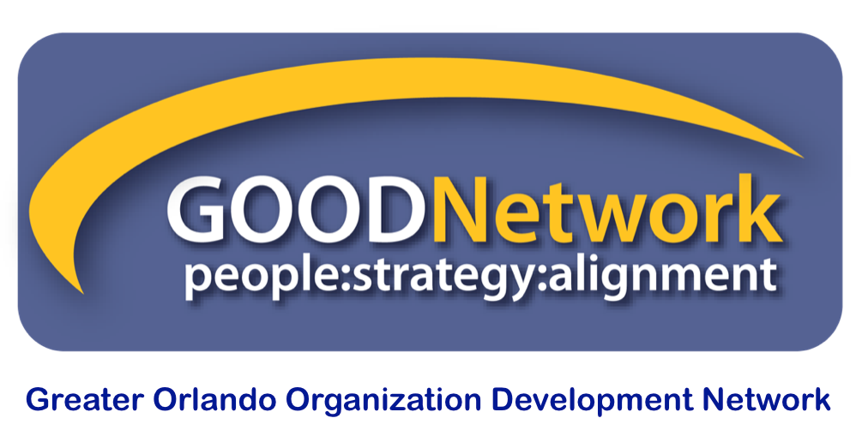

FOR PRESENTERS FOR GOOD BI-MONTHLY PROGRAMS, SPECIAL EVENTS,
AND WEBINARS

GOOD’s programs committee is continuously accepting proposals from OD/organizational effectiveness professionals who have proven facilitation skills and would like to be considered for presentation at GOOD bi-monthly meetings, special events, and webinars in the Orlando, FL area.

Do you have evidence-based case studies, theories in action, actionable research insights, tangible tools, and/or experiential learnings? We would love to hear from you if you have an idea for an engaging and interactive learning event designed for audiences of 60-100 participants over a 2 hour time period (GOOD is also interested in offering special events with audiences of around 15-30 individuals and webinars).

GOOD’s membership includes many individuals with extensive experience in OD and who possess advanced degrees in areas such as human resource management, organizational development and leadership, and industrial/organizational psychology. We are a group of professionals who value evidence-based OD practice. We want you to help us make stronger connections between the research and practice without pushing a product/service.

GOOD bi-monthly programs occur on the second Fridays of the following months: January, March, May, July (Best Practices), September, November. These morning events run from 9 a.m. – 12 p.m. with a 15 minute break.

GOOD membership is optional but highly encouraged. Please reference our GOOD Programs Website for information on previous programs.

Task | Due date | Special instructions/comments
Your proposal | By December 1 for Programs between January-March  By March 1 for Programs between April-June  By June 1 for Programs between July-September  By September 1 for Programs between October-December | Please submit an electronic version of your presentation proposal to: bimonthlyprogram@goodnetwork.us. Make sure the subject line includes: “GOOD Programs - Presentation Proposal - <<Title of the session>>”
Selection decision |  | Your proposals will be reviewed by the GOOD Programs Committee. Proposals will be selected based on their relevance to GOOD’s mission, relevance to GOOD’s members request (based on an annual member survey), clarity, originality, and engaging format of the presentation. The GOOD Programs Committee may conduct follow-up interviews with potential presenters prior to making final decisions.
Submit presentation materials | No later than 4 weeks prior to your presentation | Selected candidates will need to provide their presentation materials electronically.

For further information, please contact the GOOD Director of Programs at bimonthlyprogram@goodnetwork.us.

PRESENTATION PROPOSAL FORM

Presenter’s Contact Information

Name |  | Phone
Company |  | Email
Job Title |  | Website

Will you have a co-presenter? Yes No
If yes, please duplicate this form for your co-presenter.

Availability: (check all that applies)

Virtual Yes/No In-Person Presentation Yes/No Special Event Presentation Yes/No

January__ February__ March__ April__ May__ June__
July__ August__ September__ October__ November__

Presenter Biographical Information:
Please provide a 150 to 200 word professional bio which should include current position, expertise, past experience, education and recent awards. This bio will be used for introduction purposes and should demonstrate your credibility and help build rapport with the audience.

Speaking history:

Event Name | Date | Approximate # in audience | Title of presentation

References:
Please provide at least two references from recent speaking engagements and/or clients. Preferably, at least 1 of these references should address the presentation topic you plan to present at the GOOD program.

Reference Name | Phone | Email | Title of presentation

About the Presentation

- Title of the Session:

- Summary of the Session:
In 200 words or less, provide a summary of the content. If you are selected to present, the description submitted will be used in promotional flyers, the conference brochure and on the GOOD website. {The Programs Co-Chairs reserve the right to make alterations.}

- Session Tag Line:
Please provide a compelling, one-sentence primary objective of your presentation.

- Please name three learning objectives for your session.
Briefly outline the three key concepts participants will carry with them back to their workplace and how those concepts can be translated to varied workplaces?

- Briefly describe interactive components of your proposed session that would engage the audience in discussion or activity. Please include approximate length of time for each component.

- What Media or Materials accompany your presentation? What will the Programs planning team need to know in order to better support you and your audience?

