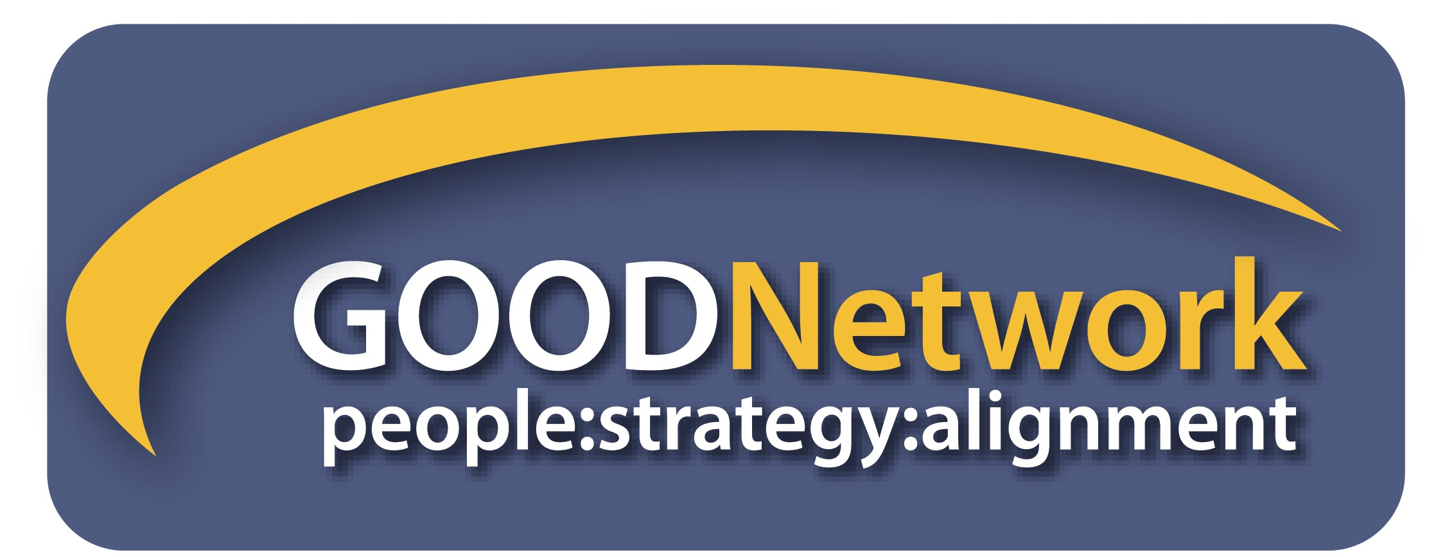
13th ANNUAL BEST PRACTICES SESSION June 8, 2018
CALLING FOR PRESENTERS
Each year our members tell us that they want to hear presentations from the talent within the GOOD Network. We hear you! We are excited to announce a call for presenters for our June bimonthly meeting.
What OD interventions have you performed in your organization or with your clients that have been effective? Tools? Tips? Techniques? Activities? Processes? What OD related topic or activity might you want to present or facilitate to our group?
Thank you for considering to be a presenter at this event! Here is what you need to know:
Requirements for presenters:
- A Presentation between 15-30 minutes in length to a full audience (50-100 people) that is both informational and interactive;
- Power Point slides to support the presentation;
- Commitment to attend the full session from 8:30am-12:30pm on June 8;
- Participation on June 8 in “science fair” style discussions after presentations – to allow members to ask individual questions and to allow you to provide custom responses. (Handouts, displays, and your business cards are optional for this part of the session.)
If you are interested in participating as a presenter, please send the following information to bestpractices@goodnetwork.us no later than Monday, April 30, 2018:
Your name_______________________________ Your Email _______________________
Your phone ______________________________

Include a 5-6 sentence overview of your topic and choose one category for your topic:

___ Change / Change management  ___ Coaching  ___ Consulting skills (internal or external)  ___ Culture or culture change  ___ Emotional intelligence  ___ Leadership / Leadership development | ___ Learning or training  ___ Organizational development  ___ Recruitment, retention, talent management  ___ ROI / measurement  ___ Succession planning  ___ Team building  ___ Other ______________________________

You will be contacted as soon as possible on the status of your proposal. Remember that we will review and select presenters that we believe will meet the needs of our members based on our member survey and our understanding of member interests. If you are selected to present, your presentation materials will be due on May 28, 2018. Don't miss this opportunity!

