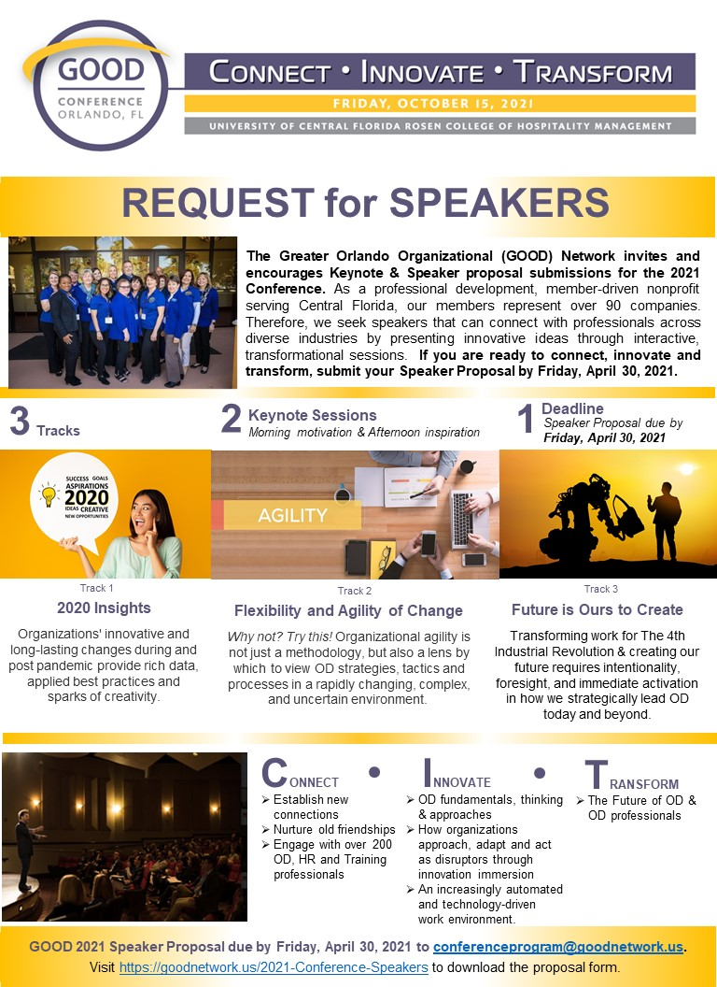

CALL FOR PRESENTERS FOR GOOD 2021 GOOD CONFERENCE

THEME: CONNECT * INNOVATE * TRANSFORM

The Greater Orlando Organization Development (GOOD) Network’s conference committee is seeking proposals from OD/organizational effectiveness professionals who have proven facilitation skills and would like to be considered to make a presentation at GOOD’s 2nd Conference in the Orlando, FL area.

Three session tracks are at the heart of this day long development and networking event:

- Track One - 2020 Insights
  - Organization’s innovative and long-lasting changes during and post pandemic provide rich data, applied best practices and sparks of creativity. In this track, we look at how OD adapts our foundational disciplines and core practices to meet ever changing needs, linking our strong past with the present.
  - Ideal for presenting real life case studies from 2020

- Track Two - Flexibility and Agility of Change
  - Organizational agility is not just a methodology, but also a lens by which to
view OD strategies, tactics and processes, in a rapidly changing, complex and uncertain environment. This track will explore how organizations approach, adapt and act as disruptors
through innovation immersion. Learn how concepts such as artificial intelligence, machine learning and emerging technologies transform OD solutions.
  - Ideal for a “no Power Point” approach that is highly interactive with breakout groups to allow participants to try a new technique

3. Track Three –Future is Ours to Create
  - Strategic leadership is critical to transforming the workforce, workplace and work of The 4th Industrial Revolution. Creating our future also requires intentionality, foresight and immediate
activation in how we lead OD today and beyond. This track will explore how radical
innovation of skills, and shifting the context of the workplace, redefines work within an increasingly automated and technology-driven environment.
  - Ideal for theoretical new ideas with immediate practical application and interactive discussion

What we are looking for: Do you have evidence-based case studies, theories in action, actionable research insights, tangible tools, and/or experiential learnings that would appeal to those new to OD, or those looking to push the boundaries of what’s next for our industry? Do you focus on further integration of our discipline for business impact? We would love to hear from you if you would like to provide one or more of the following:
- Keynote speech: One hour long session
- Breakout Track Sessions: 45 minute engaging and interactive learning experience. Can include PowerPoints or none with only interactivity.

Who we are: GOOD’s membership includes over 200 individuals with extensive experience in OD and who possess advanced degrees in areas such as human resource management, organizational development and leadership, and industrial/organizational psychology. We are a group of professionals who value evidence-based OD practice. We are a community who values sharing knowledge freely with each other. We want you to help us make stronger connections between the research your product/service is based on while respecting our values of a solicitation free environment.

When and where is the GOOD Conference? The GOOD Conference is planned for October 2021 from 8:30am to 4:30pm at UCF’s Rosen College of Hospitality Management, 9907 Universal Blvd, Orlando, FL 32819.

Why should I present? Speakers will receive three key benefits:
- Complimentary admission to the conference, including breakfast, lunch, and refreshments
- Exposure to hundreds of Central Florida business professionals engaged with OD
- Development and growth for your professional career by showcasing your work

Join us: GOOD membership is optional but highly encouraged. Please reference our GOOD Programs Website for information on previous programs.

Task | Due date | Special instructions/comments
Your proposal for Keynote and/or Workshop | By Friday, April 30, 2021 | Please submit an electronic version of your presentation proposal to: conferenceprogram@goodnetwork.us. Make sure the subject line includes: “GOOD Programs - Presentation Proposal - <<Title of the session>>”
Selection decision | By Friday, June 11, 2021 | Your proposal will be reviewed by the GOOD Conference Committee. Proposals will be selected based on their relevance to GOOD’s mission, relevance to the purpose of the Conference, clarity, originality, and engaging format of the presentation. The GOOD Conference Committee may conduct follow-up interviews with potential presenters prior to making final decisions.
Submit presentation materials | Friday, September 3rd, 2021 | Selected candidates will need to provide their presentation materials electronically.

For further information, please contact the conference committee at conferenceprogram@goodnetwork.us.

PRESENTATION PROPOSAL FORM

Note: GOOD Network is not anticipating offering speaker stipends as we are a non-profit and have a limited conference budget.

If you have co-presenters, please duplicate this form for your co-presenter (s) so we have all of their details.

Primary (Main) Speaker (This person will receive COMPLIMENTARY registration for the conference):

Name |  | Phone
Organization |  | Email
Title |  | Website
LinkedIn |  | Facebook and/or Instagram
Webinars |  | TED Talks

Will you have a co-presenter (s)? Yes ☐ No ☐

If yes, list their names and emails below. These co-presenters will be required to register at the $100 speaker rate.

Co-Presenter 1 Name:
Co-Presenter 1 Email:

Co-Presenter 2 Name:
Co-Presenter 2 Email:

Co-Presenter 3 Name:
Co-Presenter 3 Email:

If a group of co-presenters, please indicate which individual/organization should receive the invoice:

Name:
Organization Name:
Email

Presenter Biographical Information:
Please provide a 150 to 200 word professional bio which should include current position, expertise, past experience, education and recent awards. This bio will be used for introductions and website overview.

Speaking history:

Event Name | Date | Approximate # in audience | Title of presentation

References:
Please provide at least two references from recent speaking engagements and/or clients. Preferably, at least 1 of these references should address the presentation topic you plan to present at the GOOD program.

Reference Name | Phone | Email | Title of presentation

About the Presentation

Title of Session:

Type of Session: Keynote ☐ Breakout Track One ☐ Breakout Track Two ☐ Breakout Track Three ☐

Is Your Session Able to be delivered Virtually/Online if required? Yes ☐ No ☐

Are you willing to be photographed at the conference with photos used for marketing purposes?

Yes ☐ No ☐ Maybe (would like to discuss further) ☐

Are you willing to be videotaped at the conference with videos used for marketing purposes?

Yes ☐ No ☐ Maybe (would like to discuss further) ☐

Summary of the Session:
In 200 words or less, provide a summary so we can understand your areas of focus. If you are selected to present, the description will be referenced for marketing purposes. {The Conference Committee may make minor alterations.}

Presentation Brief Marketing Blurb:
Please provide a compelling, one to two sentence marketing statement that we can publish on our website along with your bio.

Please describe at least one main point or new idea the audience can expect to discover from your presentation.
Briefly outline the concepts participants will carry with them back to their workplace and how those concepts can be translated to varied workplaces.

Briefly describe interactive components of your proposed session that would engage the audience in discussion or activity. Please include approximate length of time for each component.

What Media or Materials accompany your presentation? What will the Programs planning team need to know in order to better support you and your audience?

