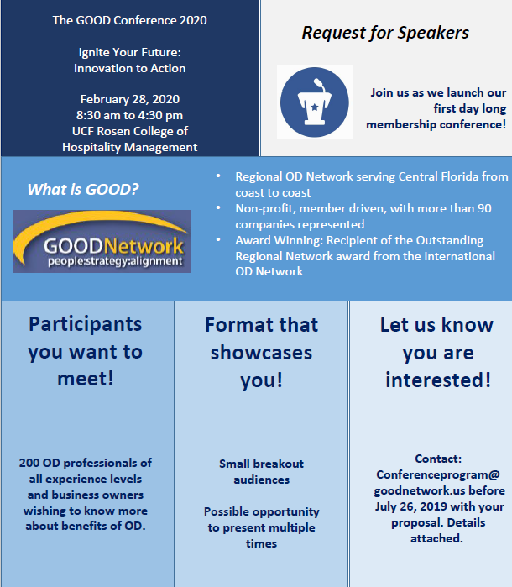

CALL FOR PRESENTERS FOR GOOD 2020 GOOD CONFERENCE - IGNITE YOUR FUTURE

The Greater Orlando Organization Development (GOOD) Network’s conference committee is seeking proposals from OD/organizational effectiveness professionals who have proven facilitation skills and would like to be considered to make a presentation at GOOD’s 1st Conference in the Orlando, FL area.

Two session tracks are at the heart of this day long development and networking event:
- Track One - Introduction to and Application of OD Principles
  - Best for those newer to the field
- Track Two - What’s Trending for the Future of OD
  - Best for experienced practitioners

What we are looking for: Do you have evidence-based case studies, theories in action, actionable research insights, tangible tools, and/or experiential learnings that would appeal to those new to OD, or those looking to push the boundaries of what’s next for our industry? Do you focus on further integration of our discipline for business impact? We would love to hear from you if you would like to provide one or more of the following:
- Keynote speech: One hour long session
- Workshops: 45 minute engaging and interactive learning experience. Multiple presentations possible.
- See topics list on pages 3 and 4 to align your topic with either Track One or Track Two above

Who we are: GOOD’s membership includes over 200 individuals with extensive experience in OD and who possess advanced degrees in areas such as human resource management, organizational development and leadership, and industrial/organizational psychology. We are a group of professionals who value evidence-based OD practice. We are a community who values sharing knowledge freely with each other. We want you to help us make stronger connections between the research your product/service is based on while respecting our values of a solicitation free environment.

When and where is the GOOD Conference? The GOOD Conference is planned for February 28, 2020 from 8:30am to 4:30pm at UCF’s Rosen College of Hospitality Management, 9907 Universal Blvd, Orlando, FL 32819.

Why should I present? Speakers will receive three key benefits:

- Complimentary admission to the conference, including breakfast, lunch, and refreshments
- Exposure to hundreds of Central Florida business professionals engaged with the area of Organizational Development
- Development and growth for your professional career by showcasing your work

Join us: GOOD membership is optional but highly encouraged. Please reference our GOOD Programs Website for information on previous programs.

Task | Due date | Special instructions/comments
Your proposal for Keynote and/or Workshop | By Friday, July 26, 2019 | Please submit an electronic version of your presentation proposal to: conferenceprogram@goodnetwork.us. Make sure the subject line includes: “GOOD Programs - Presentation Proposal - <<Title of the session>>”
Selection decision | By August 16, 2019 | Your proposal will be reviewed by the GOOD Conference Committee. Proposals will be selected based on their relevance to GOOD’s mission, relevance to the purpose of the Conference, clarity, originality, and engaging format of the presentation. The GOOD Conference Committee may conduct follow-up interviews with potential presenters prior to making final decisions.
Submit presentation materials | October 11, 2019 (same date as GOOD Bi-Monthly Mtg) | Selected candidates will need to provide their presentation materials electronically.

For further information, please contact the conference committee at conferenceprogram@goodnetwork.us.

GOOD Network Conference – Possible Topic Categories

Wondering what to present on that will excite and engage our attendees? Please consider the following:

Possible Topics for Track One - Introduction to and Application of OD Principles
- OD 101 – Team Effectiveness Tools and Models and their application
- Survey and Research Design
- How Best to Chart the Organization Structure
- Data Analysis and Trend Identification
- Organization Development Needs Analysis Processes
- Facilitation Techniques
- Feedback Tools
- Interaction Role Play Exercises and Other Team Effectiveness Tools
- How to set goals and success criteria for an OD project
- How to Understand your Organization's Cost and Financials Structure
- How to Determine your Organization's People Culture
- Project Management: how to plan, set-up and track project progress
- How to Lead Change through unanticipated Resistance
- ROI: How to capture the right information, calculate and present the Project's Return on Investment
- Best Practices for Training People to understand and adopt new processes
- How to identify and leverage Organization resources that can advance the OD Project
- How best to solicit Executive Buy-in and Support for an OD Change
- Best Practices for Communicating a proposed OD change
Possible Topics for Track Two - What’s Trending for the Future of OD
- Cutting Edge Research
- Coaching and Advanced Facilitation
- How best to interact with the CEO to determine directions and goals
- How to do due diligence when considering a potential acquisition of a new organization
- How to read financial statements such as: Income Statement, Balance Sheet and Cash Flows
- How best to interact with Finance to determine current and future challenges to profitability, growth and sustainability
- How to build a Business Plan covering mission, goals, strategies, people plan & required financial plan.
- Advanced Analytics
- Succession Planning Best Practices
- Assessments Deep Dive
- How to introduce innovation and creative thinking in the organization
- How to influence various leadership styles in the organization
- How to build a ‘People Plan’ to solve current skills and people shortages
- How to review, assess, and evolve the organization’s brand and people culture
- Latest trends in automation and technology such as AI that will impact OD
- How to integrate departments and team currently tending to operate in their own silos and foster collaboration
- How best to get “radical candor” from employees about problems, challenges and opportunities

PRESENTATION PROPOSAL FORM

Who are you? Please provide Presenter’s Contact and Social Media Presence Information

Name |  | Phone
Organization |  | Email
Title |  | Website
LinkedIn |  | Facebook
Webinars |  | TED Talks

Will you have a co-presenter? Yes No
If yes, please duplicate this form for your co-presenter.

Presenter Biographical Information:
Please provide a 150 to 200 word professional bio which should include current position, expertise, past experience, education and recent awards. This bio will be used for introduction purposes and should demonstrate your credibility and help build rapport with the audience.

Speaking history:

Event Name | Date | Approximate # in audience | Title of presentation

References:
Please provide at least two references from recent speaking engagements and/or clients. Preferably, at least 1 of these references should address the presentation topic you plan to present at the GOOD program.

Reference Name | Phone | Email | Title of presentation

About the Presentation

Title of the Keynote or Workshop:

Summary of the Session:
In 200 words or less, provide a summary of the content. If you are selected to present, the description submitted will be used in promotional flyers, the conference brochure and on the GOOD website. {The Conference Committee reserves the right to make alterations.}

Presentation Value Proposition:
Please provide a compelling, one-sentence marketing statement that we can use to excite our audience.

Please describe at least one main point or new idea the audience can expect to discover from your presentation.
Briefly outline the concepts participants will carry with them back to their workplace and how those concepts can be translated to varied workplaces.

Briefly describe interactive components of your proposed session that would engage the audience in discussion or activity. Please include approximate length of time for each component.

What Media or Materials accompany your presentation? What will the Programs planning team need to know in order to better support you and your audience?

